**Training 10 Epochs SGD OPTIMIZER learning rate initially 0.01 .**

**Loss function MAE.**

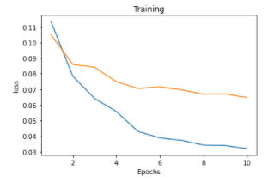

**Detailed loss:**

[1, 3500] loss: 0.11348

Avergae_validation_loss was=0.10499914056559403

[2, 3500] loss: 0.07845

Avergae_validation_loss was=0.08609046675264835

[3, 3500] loss: 0.06415

Avergae_validation_loss was=0.08417103647937377

[4, 3500] loss: 0.05577

Avergae_validation_loss was=0.07489394800116618

[5, 3500] loss: 0.04293

Avergae_validation_loss was=0.07054602902382612

[6, 3500] loss: 0.03887

Avergae_validation_loss was=0.071615315793703

[7, 3500] loss: 0.03726

Avergae_validation_loss was=0.0696718364842236

[8, 3500] loss: 0.03425

Avergae_validation_loss was=0.06685676248123248

[9, 3500] loss: 0.03392

Avergae_validation_loss was=0.06703427131225666

[10, 3500] loss: 0.03200

Avergae_validation_loss was=0.06479703924680749